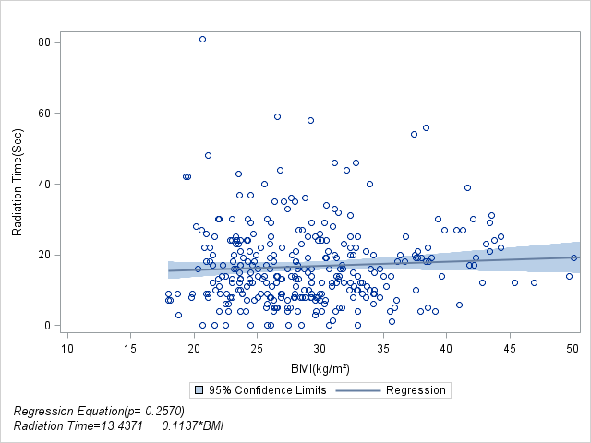

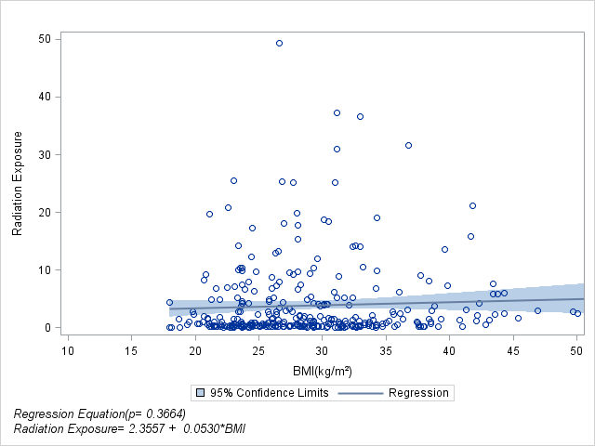

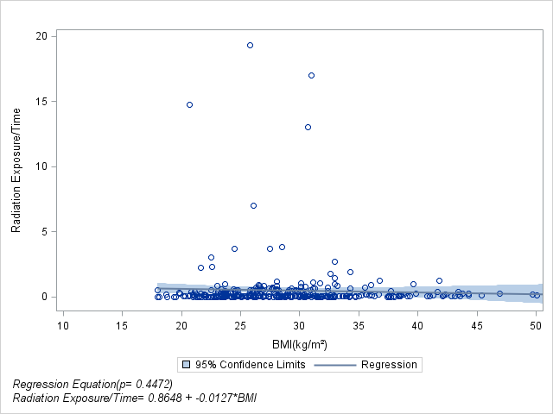

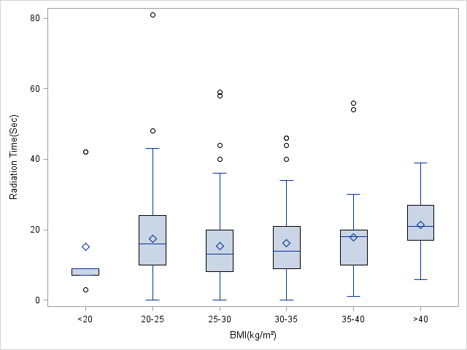

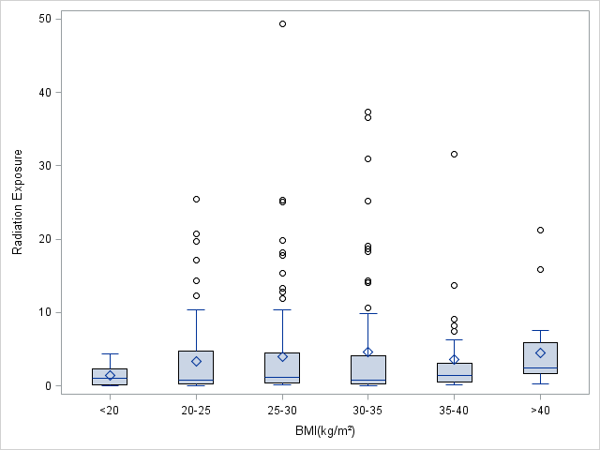

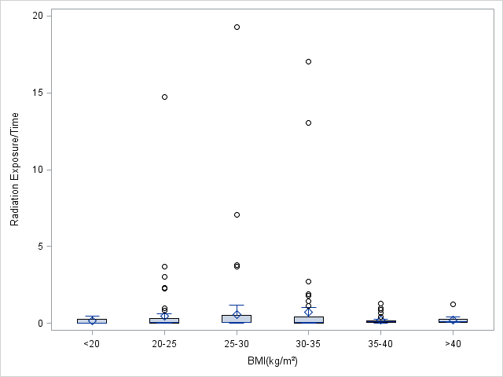

|  |  |  |  |
| --- | --- | --- | --- |
| Comparison | P value (Wilcoxon Two Sample Test) | | |
| Radiation Time | Radiation Exposure | Radiation Exposure/Time |
| BMI<20 vs BMI=20-25 | 0.1067 | 0.3758 | 0.3692 |
| BMI=20-25 vs BMI=25-30 | 0.0588 | 0.3759 | 0.0799 |
| BMI=25-30 vs BMI=30-35 | 0.3302 | 0.4107 | 0.2455 |
| BMI=30-35 vs BMI=35-40 | 0.6255 | 0.3970 | 0.3349 |
| BMI=35-40 vs BMI>40 | 0.0561 | 0.0675 | 0.3871 |